**HOMEPAGE**

I really like how this page looks and the way you’ve implemented visual hierarchy using colours, font size, and bold.

I realise that “Our Impact” was found to be of high importance in the card sorting work, but for the HomePage can we prioritise what we do, how to access help, e-newsletter sign up, and donate?

**Carousel**

I really like the carousel and the “Are you in need of support?” section. But it means we have multiple buttons leading to the same info. This was flagged as an issue on our current website so it needs to be changed.

Please can the carousel items be the following:

***Item 1:***

“Are you struggling with your housing? Maybe you’re facing homelessness?” [big writing]

“We’re here to help. Find out more about our free advice service.” [smaller writing]

***Item 2:***

“Our clients’ stories” [big writing]

“Learn about the people behind the numbers and their housing journeys” [smaller writing]

***Item 3:***

“Our impact: April 2022 to March 2023” [big writing]

“Take a look at our most recently published Impact Report to see how we helped the people of Bristol and beyond last year.” [smaller writing]

**Impact report section**

Please could you remove this? We can have it in the carousel instead. Then it keeps the buttons below very clear.

**Donate button + sign up for newsletter button**

Can these be alongside each other, as you’ve already done.

But can they be bigger and more conspicuous?

And can they be separated into two boxes, whilst still incorporating a bit of copy, like:



**Banner**

Can the banner that reads: “Housing Matters – advice, support, and advocacy in Bristol” be moved to below the donate and regular updates buttons?

**RESOURCES PAGE**

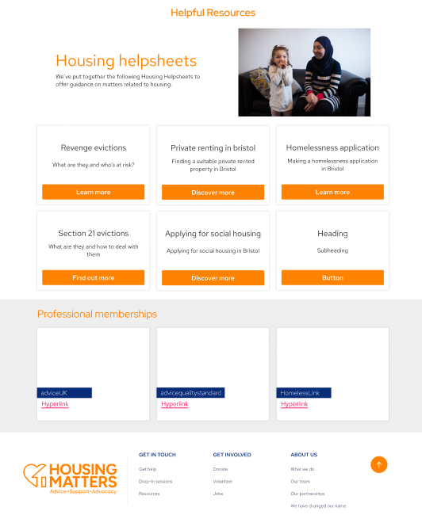

Really like how this page looks.  
However, the professional memberships section would be better in the “About us” section. As they’re not really helpful resources.

**OUR FUNDERS**

Can the funders section have its own page? In the “About us” drop-down? Because sometimes big funders will check whether we’ve included them, so they’d need to be able to find the funders section quickly.

**"CONTACT US” PAGE**

As per the feedback of the Advisory Board, can we have a page for “contact us” for general enquiries? It could be accessible via the website footer.

The page would need to specify that the admin email address is not for housing help.

Then there can be a link back to the “Get help” page for people looking for help.

**Quotes**

Where there are quotes as images, please could you write these out so that screen readers and the translation function works with them? I’ll attach the brand speech marks for you to use with them to this email.